COMP 511 Homework 1, Dan Suissa

Question 1
We study three real-world networks from the Barabási Network Science dataset collection: PowerGrid, Collaboration, and Email. Each dataset is converted into a simple, undirected, unweighted graph by (i) removing self-loops, (ii) collapsing multi-edges into a single edge, and (iii) symmetrizing the adjacency to ensure undirectedness. All computations are performed using a 0/1 sparse adjacency matrix representation (CSR format).
Some metrics are sensitive to disconnected components (e.g., shortest paths). Therefore, we follow a consistent policy across datasets: metrics (a), (b), and (f) are computed on the full graph, while metrics (c), (d), (e), and (g) are computed on the giant connected component (GCC) to avoid infinite distances and artifacts from disconnected nodes. For computational feasibility on large graphs, we use sampling for shortest paths and clustering-related metrics (details are provided in the complexity section).
(a)
We report the number of nodes nnn, undirected edges mmm, the number of connected components, and the size of the giant connected component (GCC). Table 1 summarizes these results.
Table A1 Basic graph statistics and connectivity

Dataset | Nodes n_full | Edges m_full | # Connected components | GCC size | n_GCC | m_GCC
PowerGrid | 4 941 | 6 594 | 1 | 4 941 | 4 941 | 6 594
Collaboration | 23 133 | 93 439 | 567 | 21 363 | 21 363 | 91 286
Email | 57 194 | 92 442 | 190 | 56 576 | 56 576 | 92 013

The PowerGrid network is fully connected (a single component), meaning every node can reach every other node. In contrast, Collaboration and Email are fragmented into many connected components, but both are still dominated by a very large GCC containing most nodes. This justifies computing path-based and triangle-based quantities on the GCC for stable and meaningful comparisons.
(b)
For each real-world network, I computed the degree of every node and estimated the empirical degree distribution $P\left(k\right)$by counting how many nodes have degree $k$, then normalizing by the number of nodes. We plot $P(k)$on log–log axes and fit a power-law on the tail only, i.e., for $k≥k_{min}$. In a power-law regime, $P(k)∝k^{-γ}$, which appears as a straight line in log–log scale; in our fit, the plotted line has slope $-γ$.
PowerGrid: slope $=-4.085$, $k_{min}=4$.
Interpretation: the distribution decays very quickly, indicating a relatively homogeneous network with few hubs (consistent with physical/infrastructure constraints).
Figure B1. Degree distribution $P(k)$for PowerGrid (log–log). The orange line is the fitted power-law tail for $k≥k_{min}=4$(slope $=-4.085$).
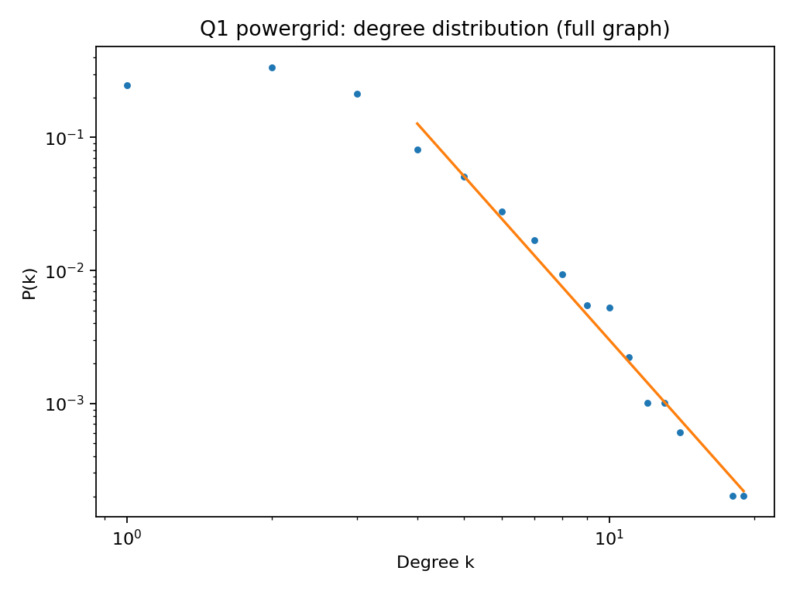

Collaboration: slope $=-2.416$, $k_{min}=11$.
Interpretation: a clear heavy-tailed degree distribution with hubs; a small fraction of authors collaborate with many others, while most have modest degree.
Figure B2 Collaboration
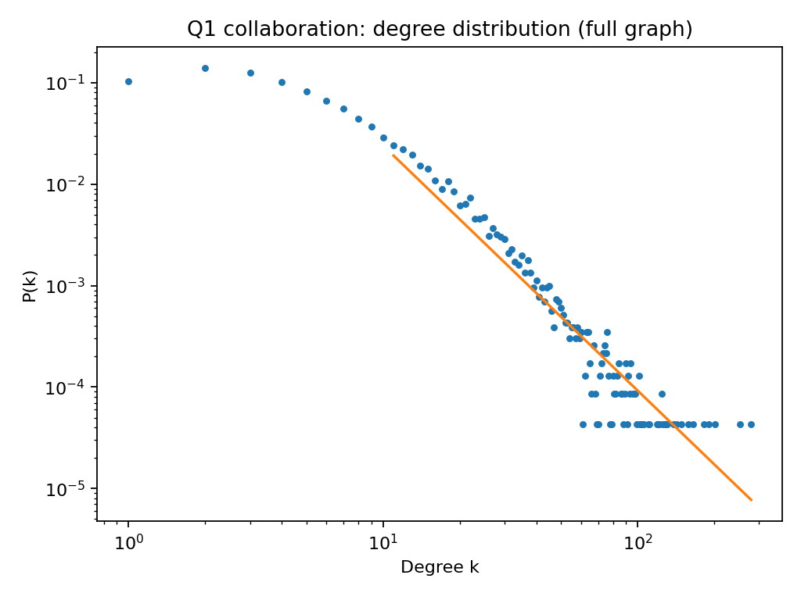
Email: slope $=-1.292$, $k_{min}=2$.
Interpretation: an even heavier tail dominated by high-degree hubs (e.g., broadcast accounts / lists). The shallow slope indicates much stronger degree heterogeneity than the other two networks.
Figure B3 Email
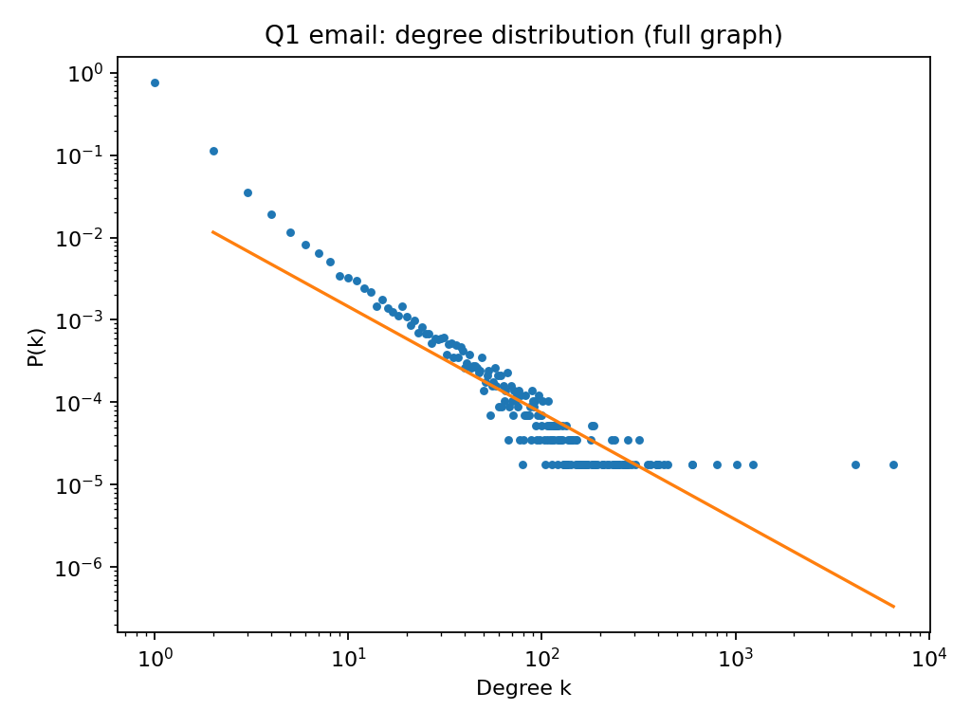

Overall, degree heterogeneity increases from PowerGrid → Collaboration → Email, visible in how slowly the right tail decays in the log–log plot.
(c)
Shortest-path lengths were computed on the giant connected component (GCC) to avoid infinite distances from disconnected nodes. For each graph, we sampled 200 source nodes uniformly at random inside the GCC and computed unweighted shortest-path distances from each source to all other nodes (BFS-style via sparse shortest-path routines). Aggregating these distances (excluding zeros), we estimate the distribution of shortest path length $l$and report the average shortest path length $⟨l⟩$on the GCC.
PowerGrid: $⟨l⟩=19.153$
Interpretation: paths are very long, consistent with an infrastructure network that is closer to a sparse, spatially constrained graph (limited long-range shortcuts).
Figure C1. Shortest path length distribution for PowerGrid (GCC, 200 sampled sources). Average shortest path length $⟨l⟩=19.153$.
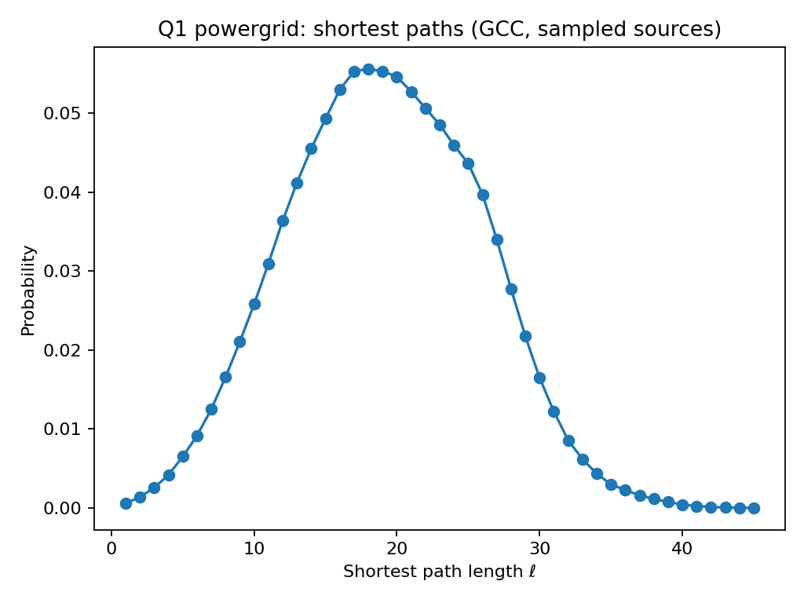
Collaboration: $⟨l⟩=5.326$
Interpretation: the graph is small-world: most nodes connect within a handful of steps due to hubs and overlapping communities.
Figure C2 Collaboration
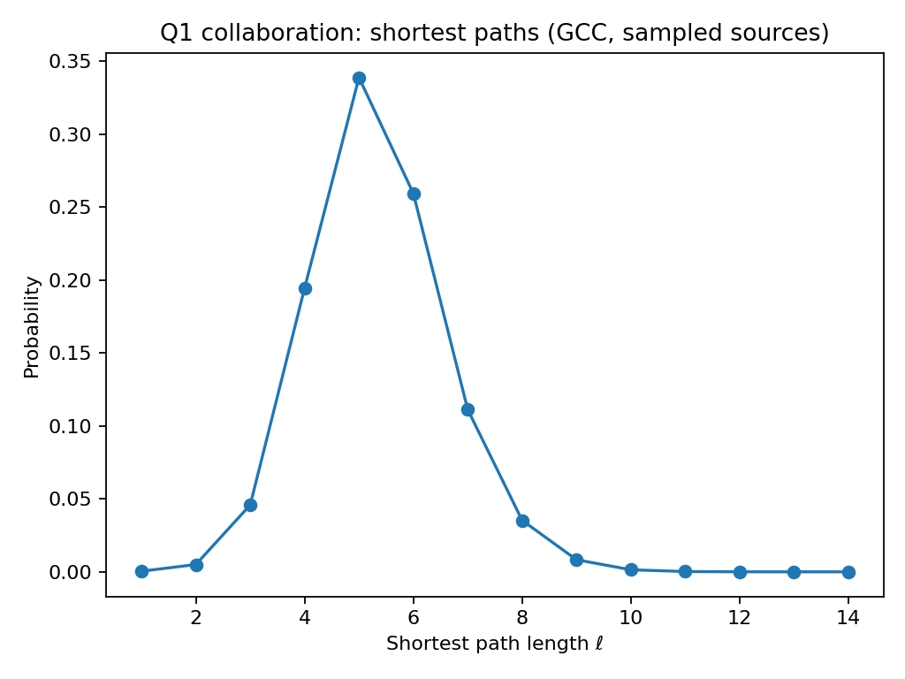

Email: $⟨l⟩=3.928$
Interpretation: even “smaller-world” than collaboration; hubs and broadcast-like connectivity strongly reduce distances, concentrating probability mass around $l≈3$–$4$.
Figure C3 Email
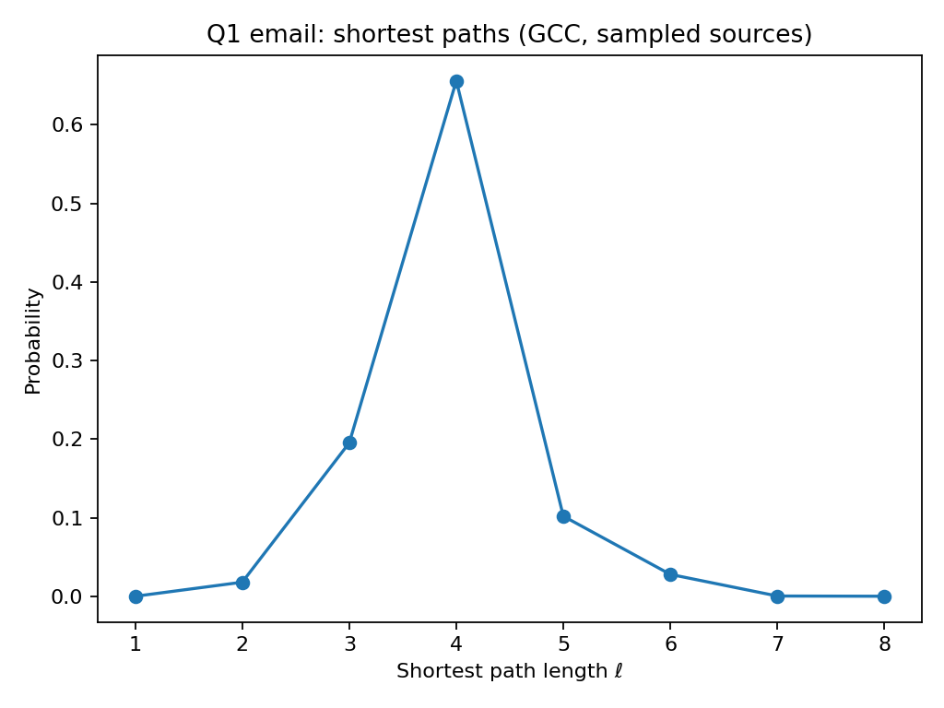

In summary, the social/communication graphs have short effective distances (few steps between most nodes), while the power grid exhibits much larger path lengths due to structural/physical constraints.
(d)
We computed local clustering on the GCC (same reason as above: focus on the main connected structure). For a sampled set of 2000 nodes in the GCC, we computed each node’s local clustering coefficient
$$c_{i}=\frac{2 T_{i}}{k_{i}(k_{i}-1)},$$
where $k_{i}$is degree and $T_{i}$is the number of edges among $i$’s neighbors. We then reported the empirical distribution of $c_{i}$(histogram on $\left[0 , 1\right]$) and the average $\overset{ˉ}{c}$.
Powergrid: $\overset{ˉ}{c}≈0.0783$(2000 sampled nodes).
Collaboration: $\overset{ˉ}{c}≈0.6353$(2000 sampled nodes).
Email: $\overset{ˉ}{c}≈0.0429$(2000 sampled nodes).
The collaboration network has very high clustering, consistent with coauthorship triangles and clique-like groups (labs/teams) where “my collaborators also collaborate with each other.” Email has low clustering, suggesting communication edges often connect across groups rather than closing triangles. Powergrid has low-to-moderate clustering: local redundancy exists but triangles are relatively rare compared to social collaboration.
Figure D1: Distribution of local clustering coefficients in the collaboration GCC (2000 sampled nodes).
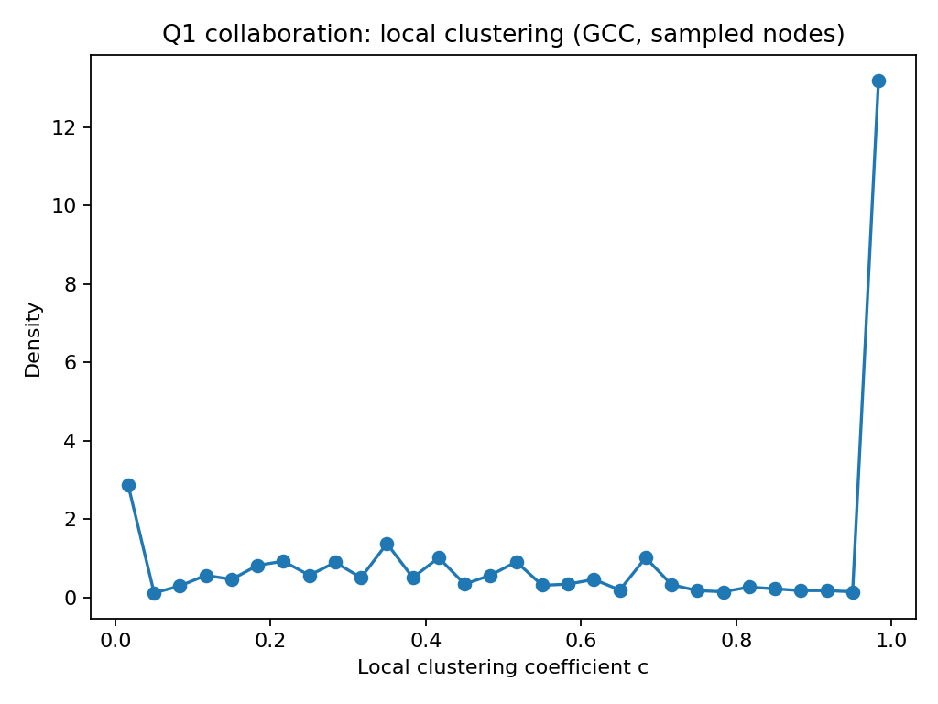
Figure D2 email
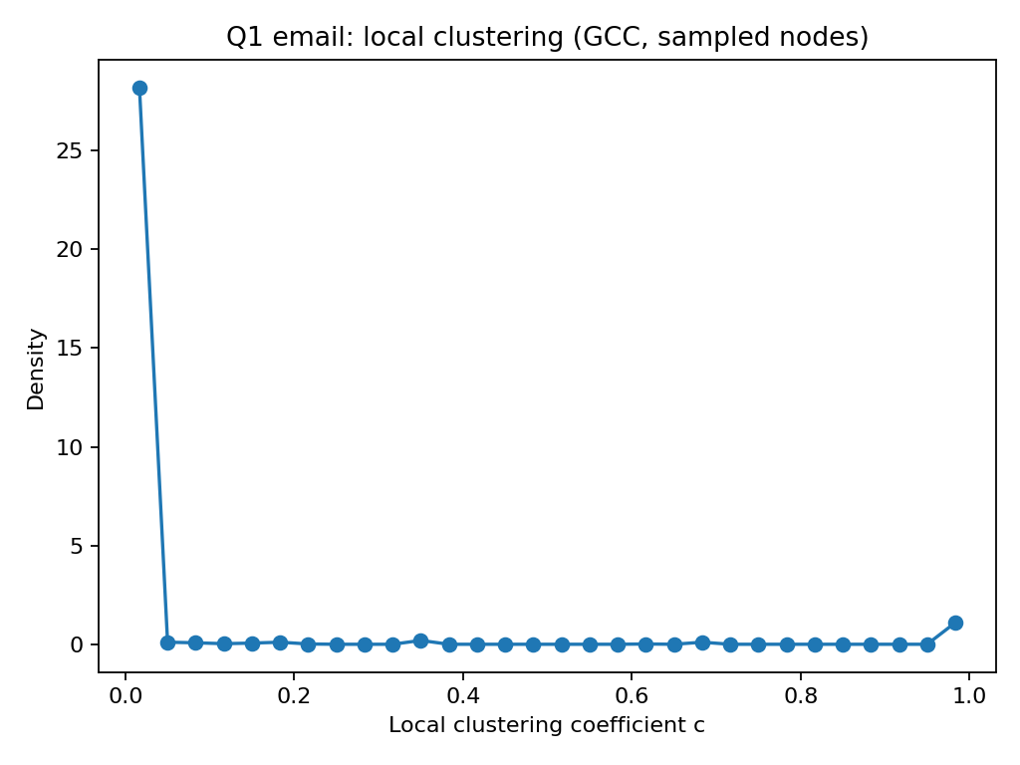
Figure D3 powergrid
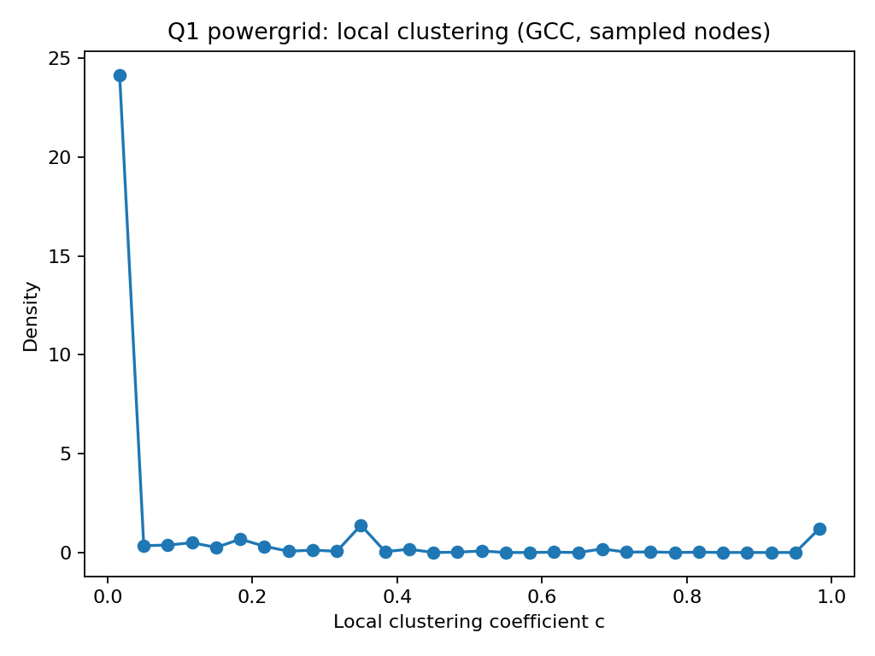
(e)
On each GCC, we computed the top $k=100$eigenvalues of the (symmetric) adjacency matrix by magnitude using sparse eigensolvers, then plotted $∣λ_{r}∣$versus rank $r$. We summarized the dominance of the leading mode with the spectral gap
$$Δ=∣λ_{1}∣-∣λ_{2}∣.$$Powergrid: $Δ≈0.8738$
Collaboration: $Δ≈7.4084$
Email: $Δ≈0.6212$
Collaboration shows a noticeably larger spectral gap, indicating a more dominant leading eigenmode (often consistent with strong hubs and/or dense core structure). Email and powergrid have smaller gaps, suggesting the top two modes are closer in strength (less domination by a single global pattern, potentially more competing structures/communities). (Note: eigenvalues scale with graph density, so the gap is the main comparable summary here.)
Figure E1: Top-100 adjacency eigenvalues (by $∣λ∣$) for the collaboration GCC; spectral gap $Δ=∣λ_{1}∣-∣λ_{2}∣$
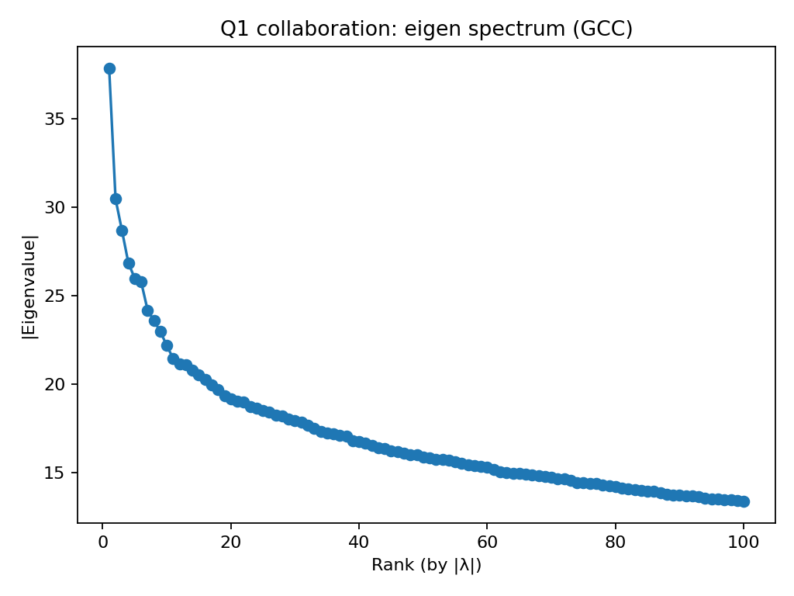
Figure E2 email
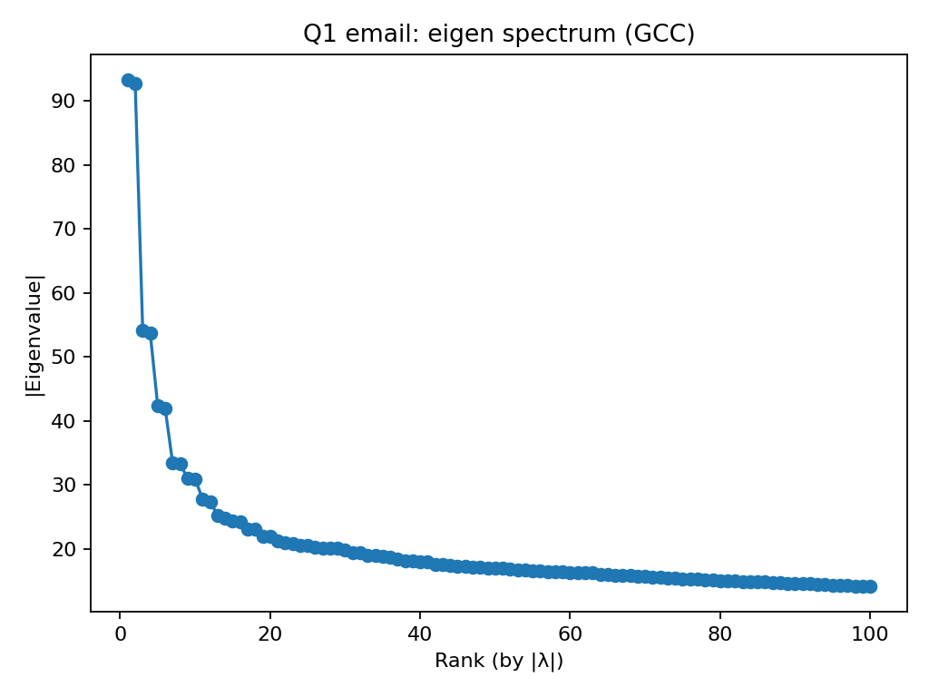
Figure E3 powergrid
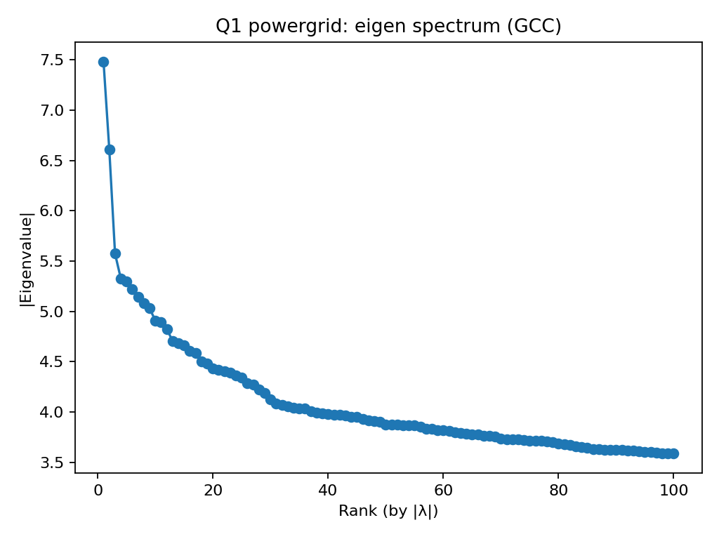
(f)
On the full graph, for each undirected edge $\left(i , j\right)$we recorded $\left(d_{i} , d_{j}\right)$. We report the Pearson correlation $corr(d_{i},d_{j})$computed over all edges (plots use sampled edges / density for readability).
Powergrid: $0.024$
Collaboration: $0.135$
Email: $-0.116$
Interpretation. Collaboration is assortative (high-degree nodes connect more to high-degree). Email is disassortative (hubs connect to many low-degree nodes). Powergrid is near-neutral (very weak degree mixing).
Figure F1 Collaboration: Degree correlation (full graph, sampled edges)
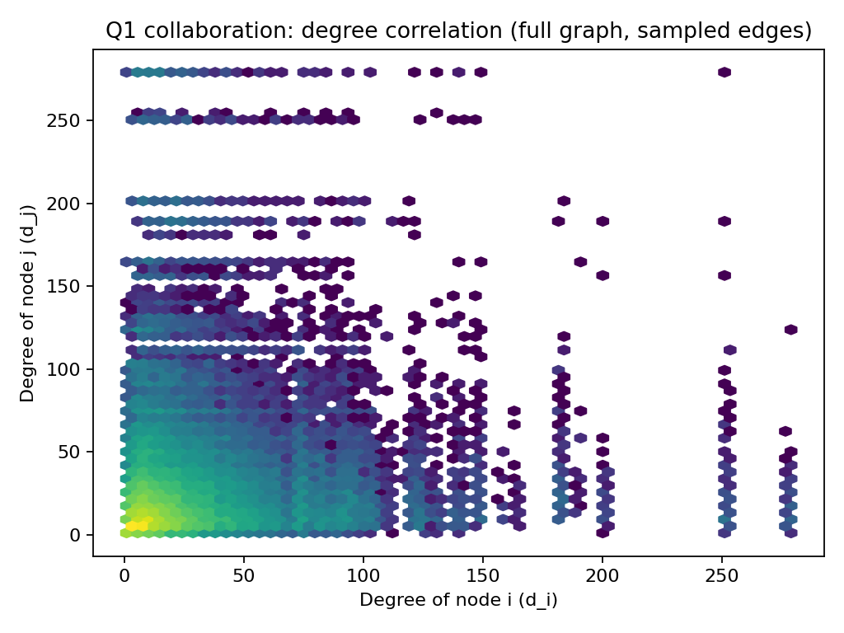
Figure F2 Email
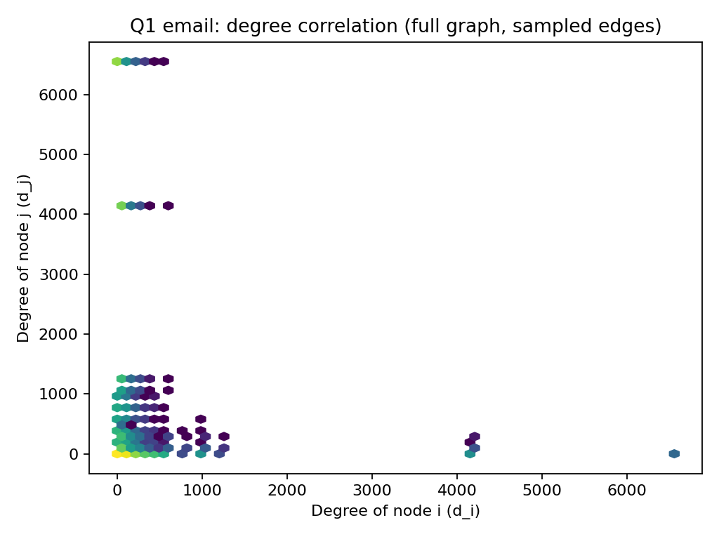
Figure F3 Powergrid
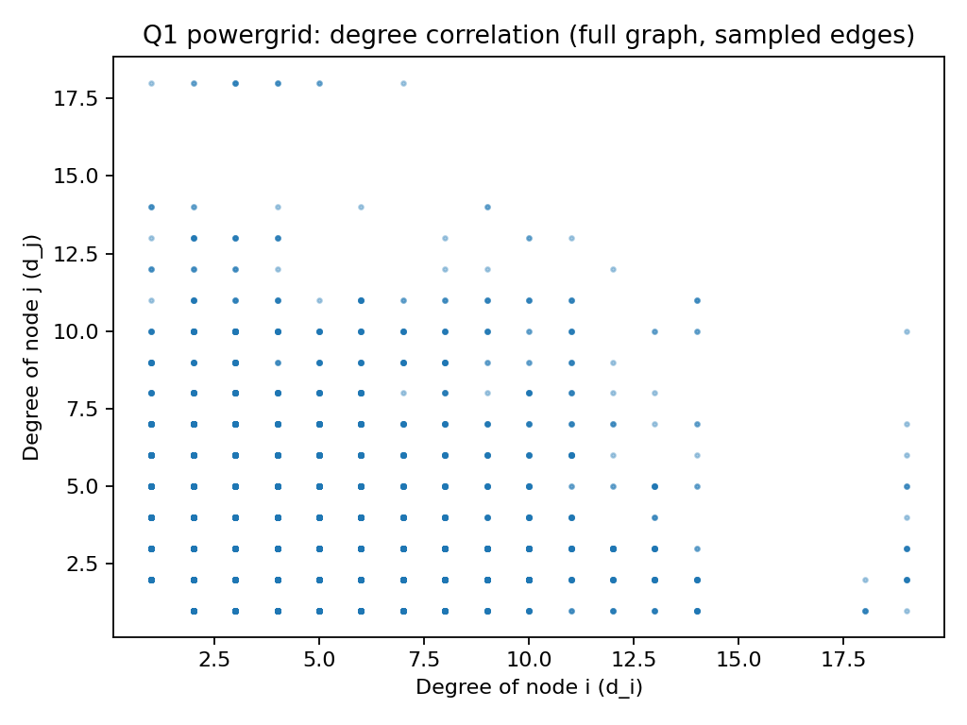
(g)
On the GCC, we computed local clustering coefficients $c_{i}$on a sampled set of nodes and plotted $\left(d_{i} , c_{i}\right)$. A binned trend line summarizes the average clustering as degree increases.
Collaboration: clear decrease of clustering with degree → high-degree authors act as bridges across groups, so their neighbors are less interconnected.
Email: clustering is near 0 for most degrees → communication is not triangle-heavy (hub/broadcast-like).
Powergrid: clustering is low overall with weak dependence on degree → triangle formation is structurally constrained.

Figure G1 Collaboration: Degree vs clustering (GCC, sampled nodes)
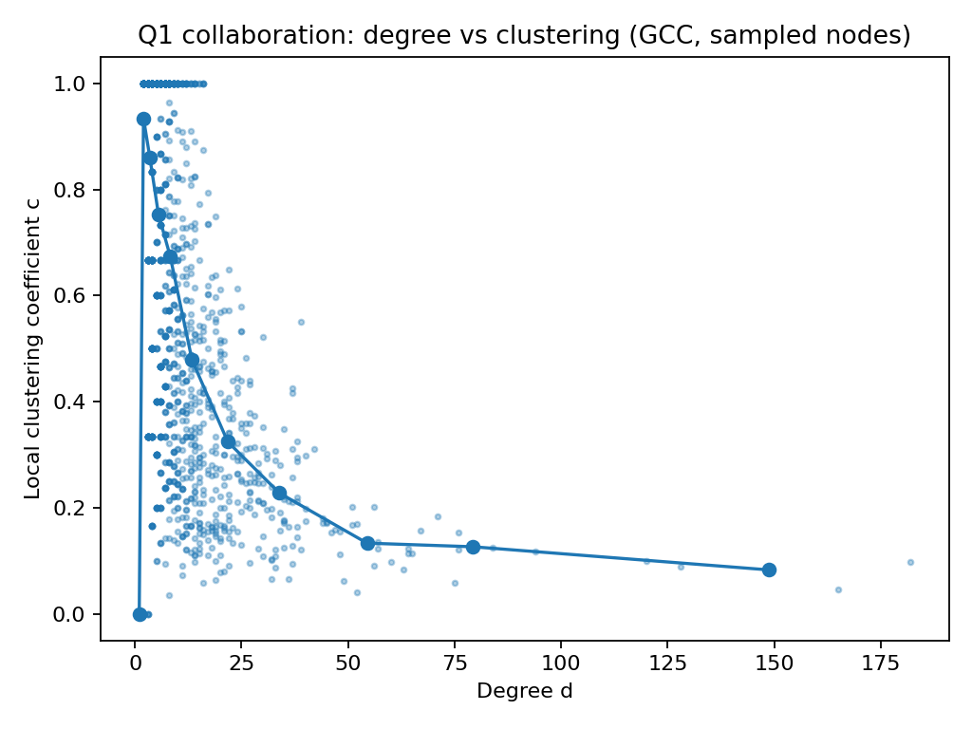
Figure G2 Email
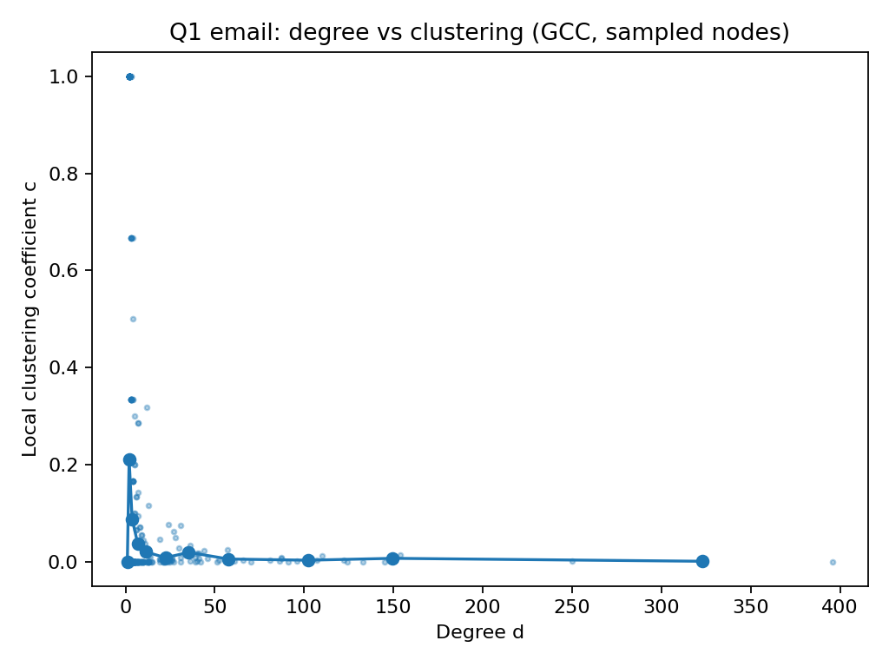
Figure G3 Powergrid
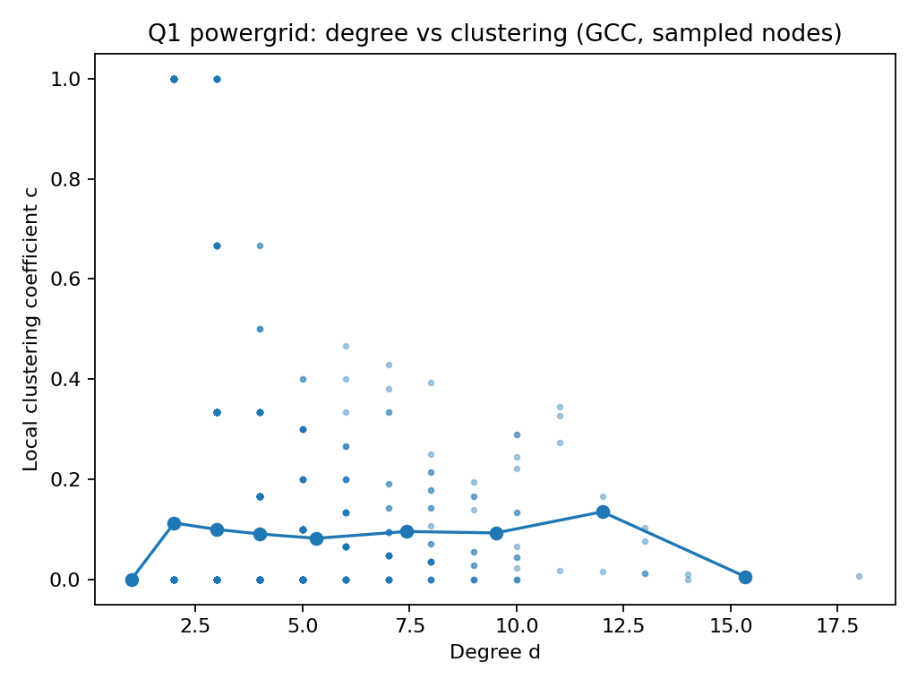

Question 2
Notation. Let $n$be the number of nodes and $m$the number of undirected edges in the graph being analyzed (full graph or GCC). The sparse adjacency matrix is CSR with $\text{nnz}=2m$nonzeros.
Loading the graphs (edgelist → simple undirected CSR adjacency)
Read edgelist (text) into two integer columns of length $m$:
Time: $O(m)$(linear in the number of rows read) Space: $O(m)$.
Build sparse adjacency (COO → symmetrize → binarize → remove diagonal → CSR):
Time: typically $O(m)$to $O(mlog⁡m)$(sorting/merging duplicates during sparse conversions can add a log factor) Space: $O(n+m)$for CSR plus transient $O(m)$arrays.
Extract GCC using scipy.sparse.csgraph.connected_components:
Time: $O(n+m)$ Extra space: $O(n)$for labels.
(When computed on the GCC, interpret $n,m$as $n_{\text{gcc}},m_{\text{gcc}}$. For sampling, let $s$=#sources for shortest paths, $t$=#sampled nodes for clustering.)
Part | What we compute (algorithm) | Time complexity | Extra space
(a) | $n,m$; #components + GCC size (connected_components) | $$O(n+m)$$ | $$O(n)$$
(b) | Degree array + histogram $P(k)$+ tail log–log fit | degrees: $O(m)$; histogram: $O(n+K)$where $K=max⁡k$; fit: $O(B)$bins / tail points | $$O(n+K)$$
(c) | Shortest-path length distribution from $s$sampled sources (shortest_path(..., indices=sources, unweighted=True)) | roughly $O(s (m+n)log⁡n)$for sparse Dijkstra-style runs (SciPy’s documented sparse methods) | dominant: distance matrix $O(sn)$
(d) | Local clustering coefficients for $t$sampled nodes (neighbor-induced subgraph counting) | $\sum_{i∈\text{sample}}{O(}d_{i}^{2})$(worst-case; depends strongly on degrees) | per-node neighbor submatrix; overall $O(max⁡d_{i}^{2})$transient
(e) | Top-$k$ eigenvalues + spectral gap via eigsh (ARPACK, implicitly restarted Lanczos) | iterative: ~ $O(\text{iters}⋅k⋅m)$(each matvec is $O(m)$) | ~ $O(kn)$(Krylov vectors)
(f) | Degree–degree correlation over edges (compute $\left(d_{u} , d_{v}\right)$for each undirected edge + corrcoef) | build edge list + arrays: $O(m)$; correlation: $O(m)$ | $O(m)$for degree-pair arrays
(g) | Degree vs clustering scatter (reuse (d) on $t$nodes + plotting/binning) | clustering cost as in (d) + $O(t)$plotting / binning | $$O(t)$$

Exercise 3
For each real dataset, I generated a BA graph using the same number of nodes $n$. The BA parameter $m$(number of edges each new node creates) was chosen using the assignment guideline:
$$m≈\frac{m_{\text{real}}}{n_{\text{real}}}$$
rounded to the nearest integer.
Powergrid: $n=4941, m=1$
Collaboration: $n=23133, m=4$
Email: $n=57194, m=2$
Note: because $m$must be an integer, the BA graphs can differ slightly in total edge count from the real graphs (most notably for email).
(a)
We measure the number of nodes/edges, number of connected components, and size of the giant connected component (GCC).
Powergrid: both graphs are connected (one component, GCC = $n$). However, BA with $m=1$is close to a sparse growth process and yields fewer edges than the real grid, meaning less redundancy than in the real infrastructure network.
Collaboration: the real graph is highly fragmented (many components, GCC smaller than $n$). The BA graph is one connected component (GCC = $n$). This shows BA does not reproduce the real-world fragmentation typical of collaboration data (e.g., separated research groups).
Email: same pattern as collaboration: the real graph has many components and GCC $<n$, while BA is connected to GCC $=n$. BA misses isolated sub-networks that exist in real email communication.
(b)
We measure the degree distribution $P(k)$plotted in log–log scale, with a linear fit on the tail; report the fitted slope and interpret the tail behavior.
Figure B1 powergrid degree distribution (full graph)
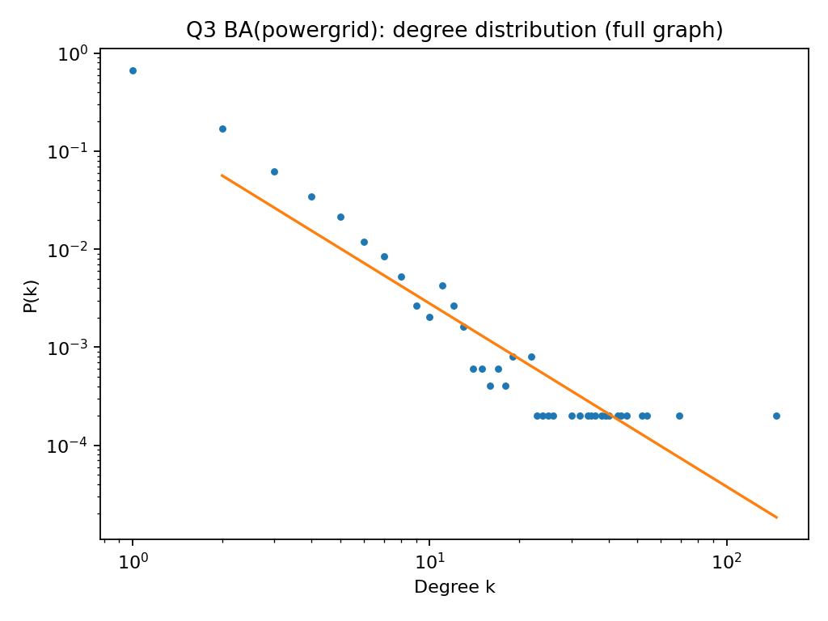
Figure B2 collaboration
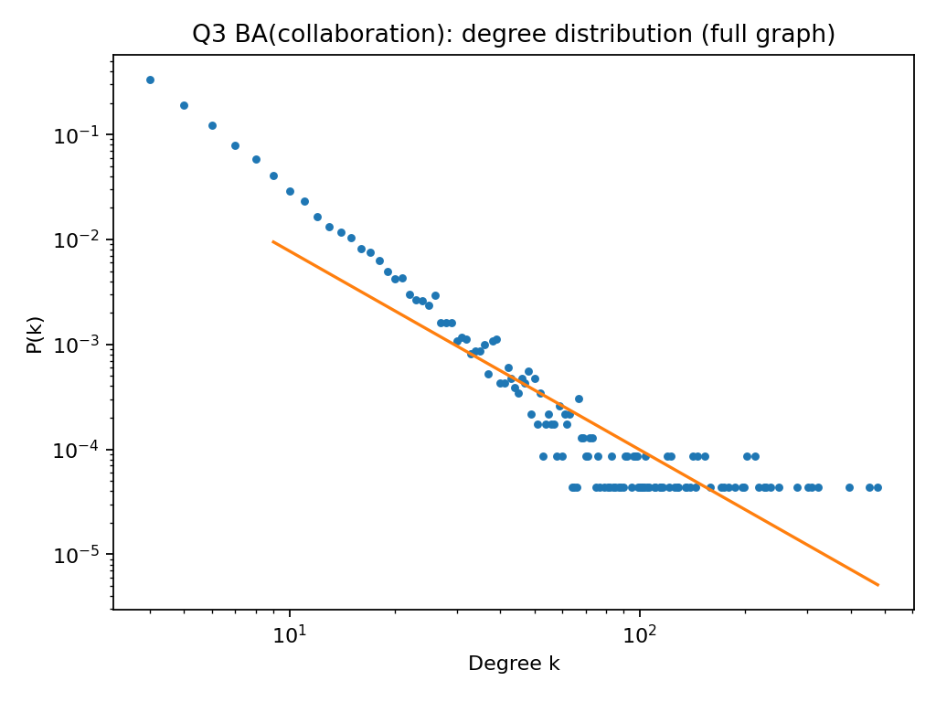
Figure B3 email
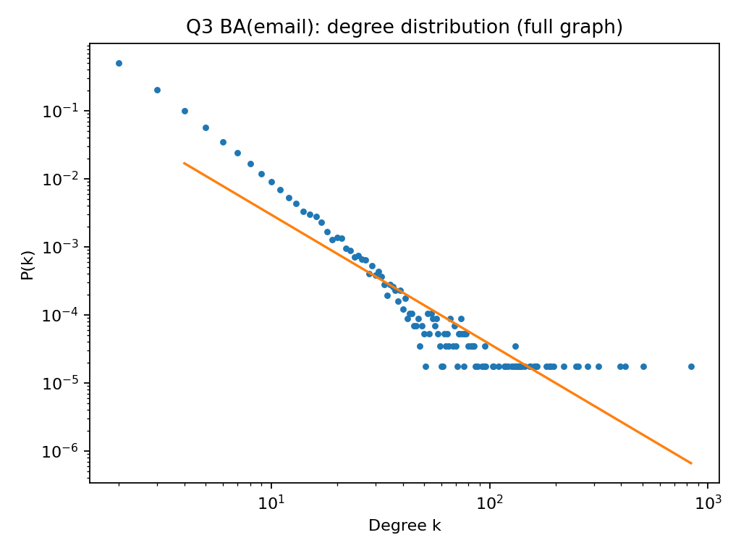
Powergrid: the real powergrid has a much steeper tail than BA. BA produces more hub-like behavior than a real engineered/spatial grid, where degree is constrained by physical and design limits.
Collaboration: both real and BA show heavy tails, but BA is typically more hub-dominated (heavier tail) because preferential attachment strongly rewards already-high-degree nodes.
Email: the real email network shows extremely strong hub effects (e.g., broadcast/list-like nodes). Here BA with $m=2$does not fully replicate the most extreme hub dominance seen in the real graph.
BA reproduces the qualitative “heavy-tailed” shape, but the strength of hub dominance can be mismatched depending on the real generating mechanisms (physical constraints vs. broadcast behavior vs. social structure).
(c)
We measure the distribution of shortest-path lengths in the GCC (sampled sources) and the average shortest path length.
Figure C1 powergrid shortest paths (GCC, sampled sources)
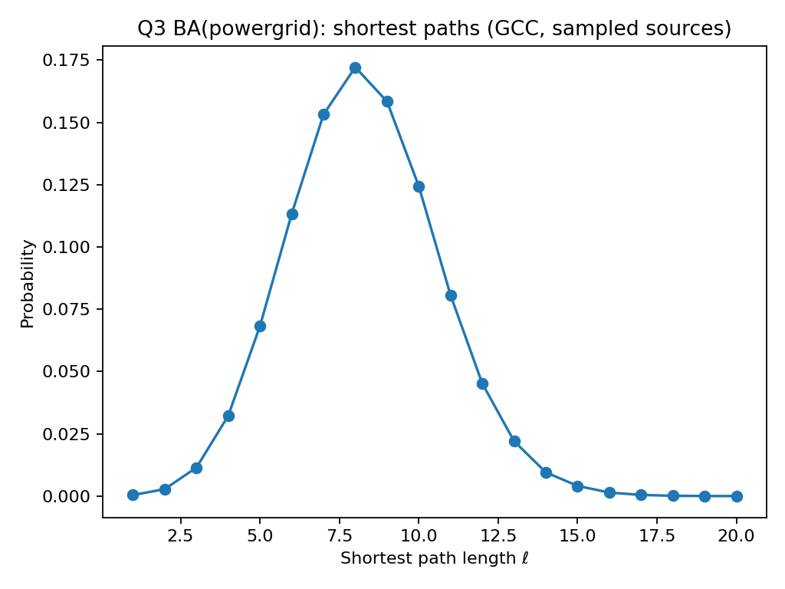
Figure C2 collaboration
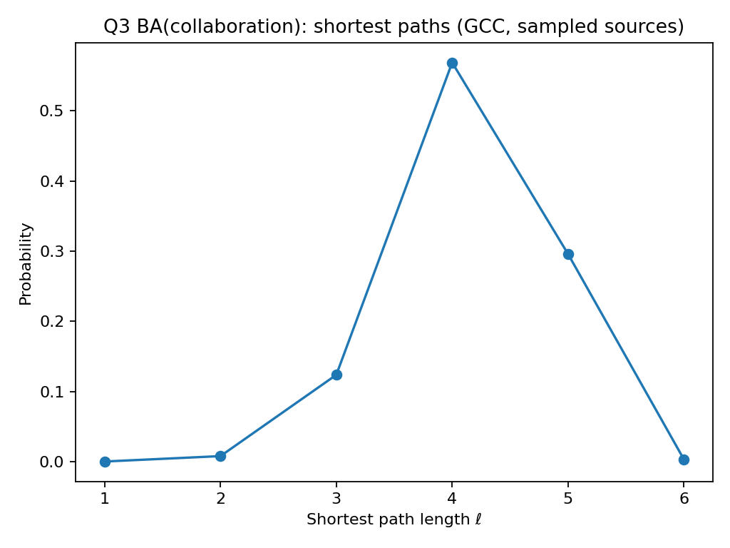
Figure C3 email
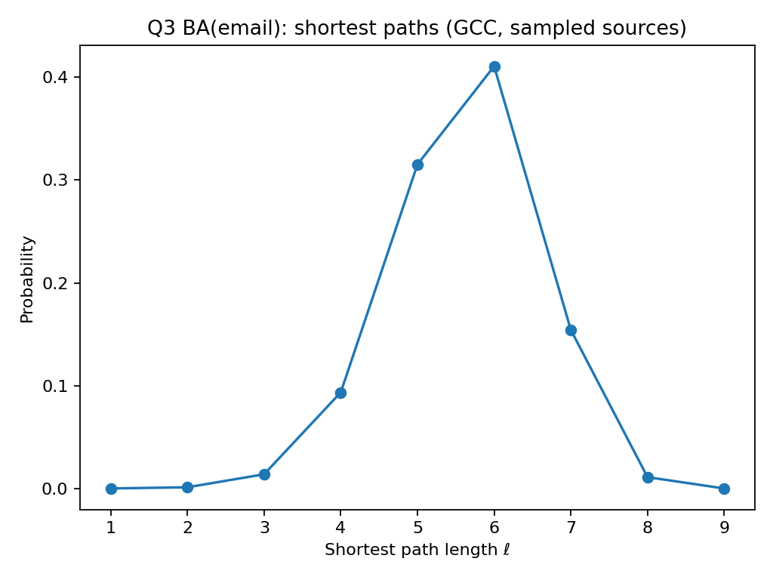
Powergrid: BA yields much shorter paths than the real grid. Preferential attachment creates hubs that act as shortcuts, while real power grids are spatial/engineering constrained and therefore have longer routes.
Collaboration: BA also shortens paths relative to the real network, consistent with hub-driven shortcutting. Real collaboration networks contain community structure and fragmentation that tends to increase distances compared to a fully connected BA baseline.
Email: the real email network has very short distances; in comparison, BA can be less “shortcut-heavy” if the real data includes unusually central broadcast actors that a basic BA process does not capture at the chosen $m$.
BA generally promotes small-world behavior through hubs but can overestimate shortcutting in spatial/engineered systems (powergrid) and underestimate shortcutting in systems dominated by broadcast-like central nodes (email).
(d)
For each BA graph, I computed local clustering coefficients $c_{i}$on the giant connected component (GCC) for a sampled set of nodes, then plotted the empirical distribution and reported the mean $\overset{ˉ}{c}$.
Figure D1 collaboration: local clustering (GCC, sampled nodes)
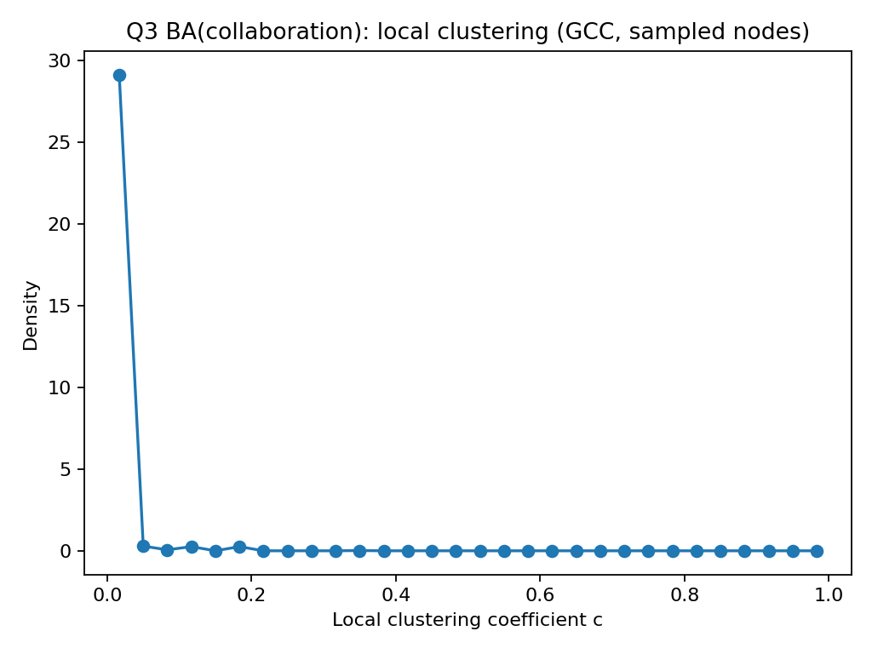
Figure D2 email
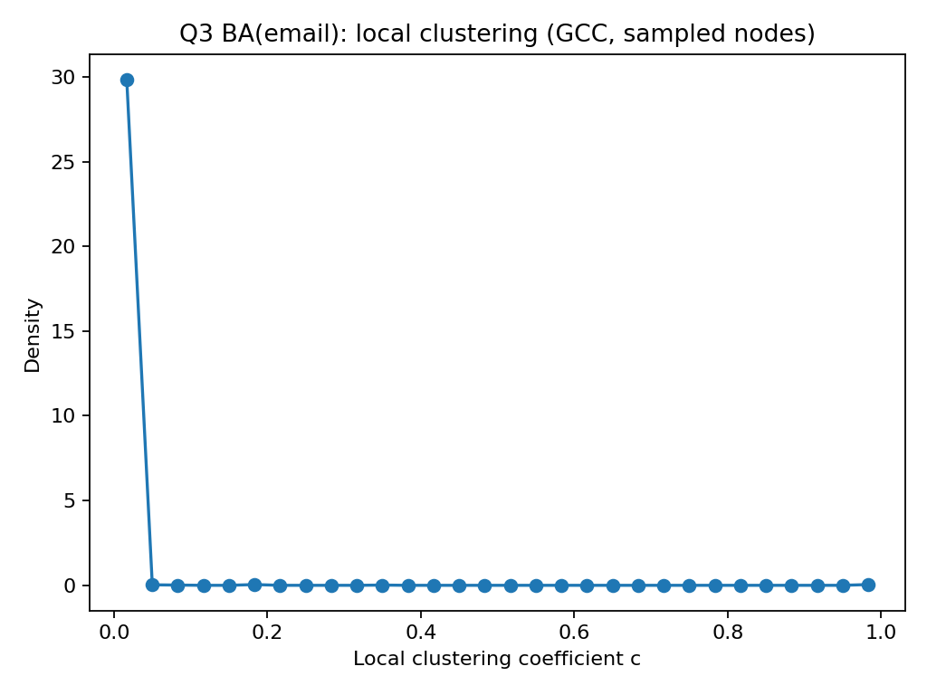
Figure D3 powergrid
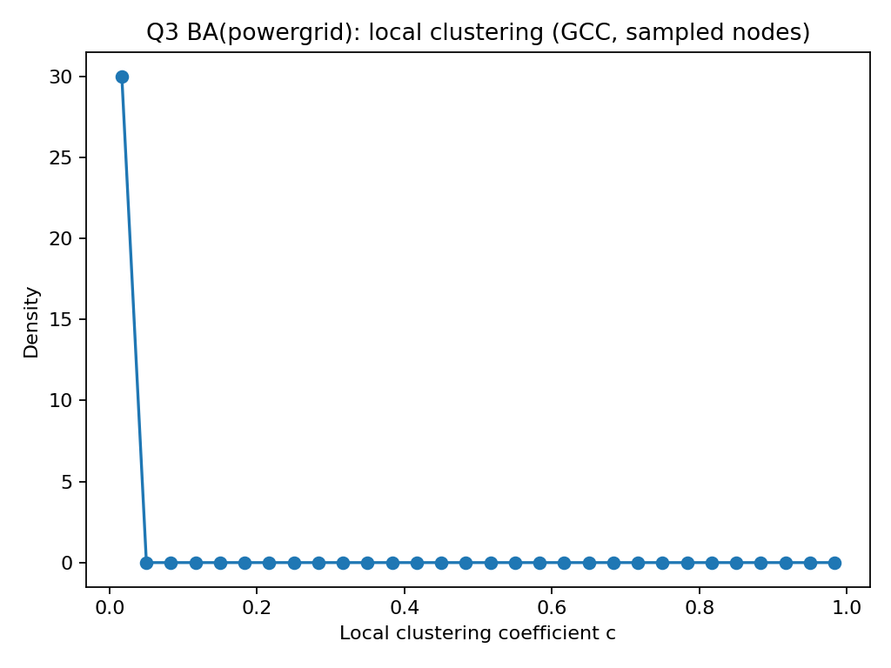
Collaboration
- BA: $\overset{ˉ}{c}≈0.0035$(distribution sharply concentrated near $c≈0$; Fig. D1).
- Real: $\overset{ˉ}{c}≈0.635$(very high clustering).
- Interpretation: preferential attachment reproduces hubs, but it does not create the dense triangle-rich “coauthor clique” structure seen in real collaboration networks.
Email
- BA: $\overset{ˉ}{c}≈0.0020$(mass near $c≈0$; Fig. D2).
- Real: $\overset{ˉ}{c}≈0.0429$(small but clearly non-zero).
- Interpretation: the real email network has more triadic closure / local group structure than BA, so BA strongly underestimates clustering.
Powergrid
- BA: $\overset{ˉ}{c}≈0$(essentially no triangles; Fig. D3).
- Real: $\overset{ˉ}{c}≈0.0783$.
- Interpretation: with $m=1$, BA generates a tree-like sparse structure (few/no triangles), while the real power grid contains nontrivial local cycles/triangles, giving higher clustering.
Across all three datasets, BA severely underestimates clustering because it captures degree heterogeneity but not triangle formation (triadic closure/community effects).
(e)
On each GCC, I computed the top 100 adjacency eigenvalues, sorted by magnitude $∣λ∣$, and plotted $∣λ∣$vs rank. I report the spectral gap
$$Δ=∣λ_{1}∣-∣λ_{2}∣.$$
Figure E1 collaboration: eigen spectrum (GCC)
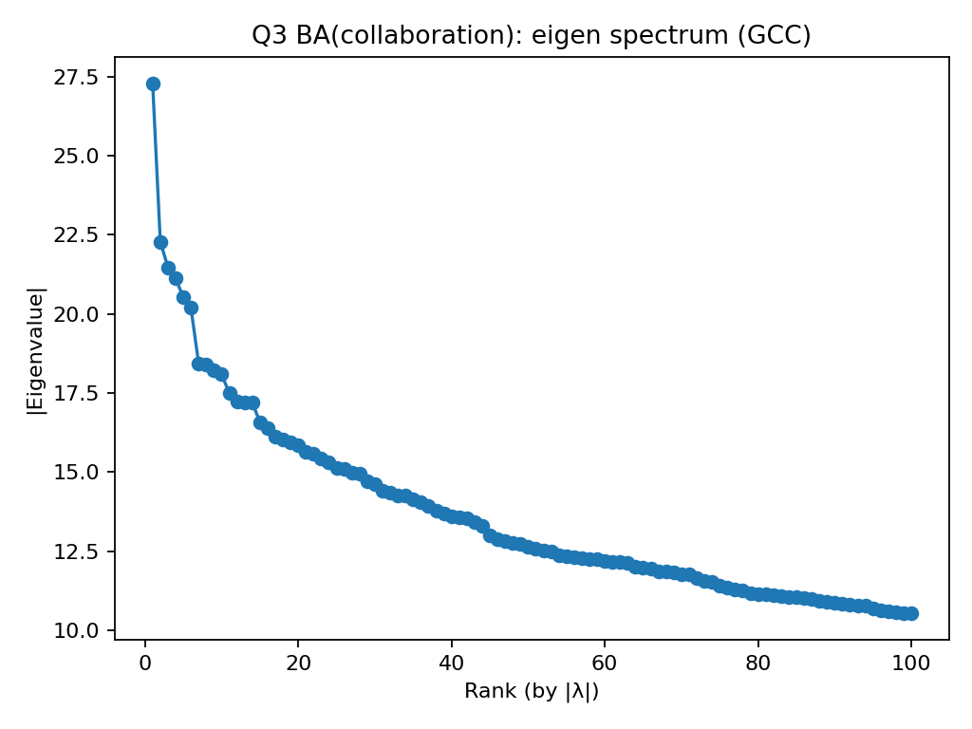
Figure E2 email
Figure E3 powergrid
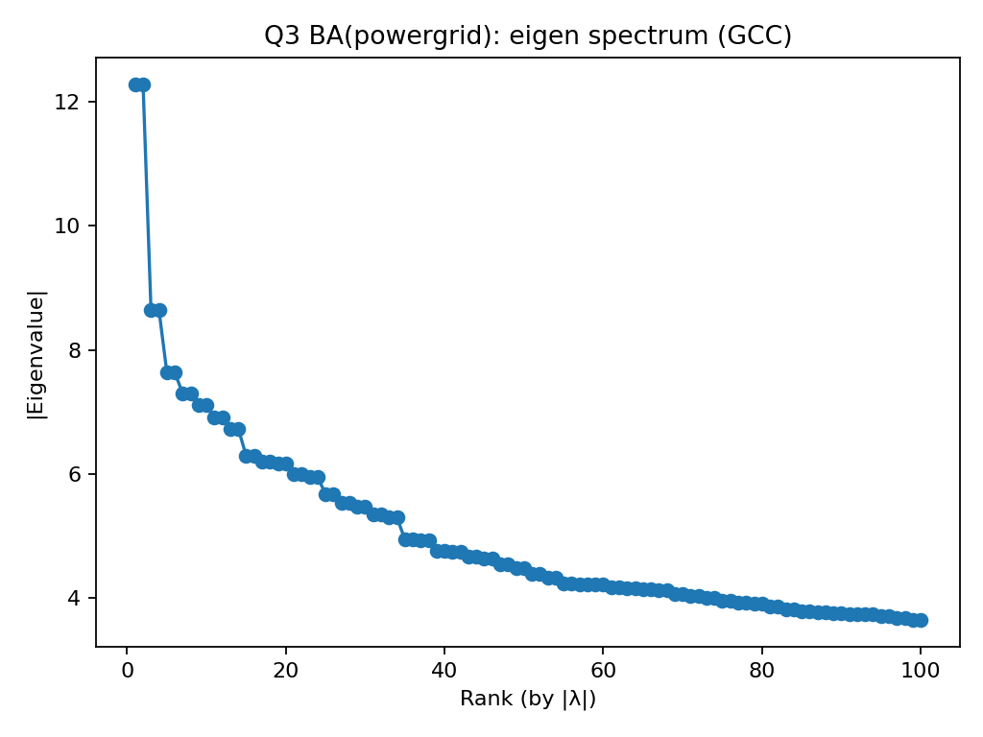
Collaboration
- BA: $Δ≈5.015$(Fig. E1)
- Real: $Δ≈7.408$
- Interpretation: BA produces a heavy-tailed degree structure and a decaying spectrum, but the real graph shows a larger leading-eigenvalue separation, consistent with stronger large-scale structure than BA captures.
Email
- BA: $Δ≈0.404$(Fig. E2)
- Real: $Δ≈0.621$
- Interpretation: BA again shows a smaller gap; the real email network has additional structure beyond pure preferential attachment.
Powergrid
- BA: $Δ≈0.000$(Fig. E3)
- Real: $Δ≈0.874$
- Interpretation: the BA(powergrid) setting ($m=1$) yields a very sparse, tree-like network whose leading eigenvalues are not well separated in our computation, unlike the real power grid.
The BA spectra decay as expected for sparse hub-forming graphs, but spectral gaps are consistently smaller than in the real networks (especially powergrid), indicating BA misses important global/meso-scale structure present in the data.
(f)
For each full BA graph, I computed node degrees, sampled edges, plotted a density-style scatter of $\left(d_{i} , d_{j}\right)$over edges, and reported the overall Pearson correlation $ρ=corr(d_{i},d_{j})$across edges.
Figure F1 collaboration degree correlation (full graph, sampled edges)
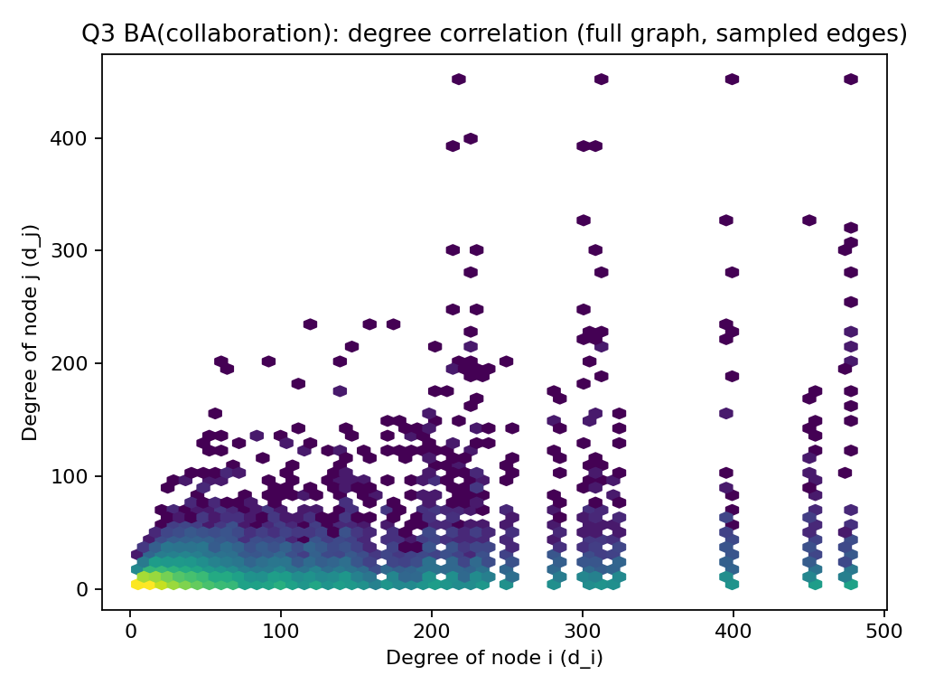
Figure F2 email
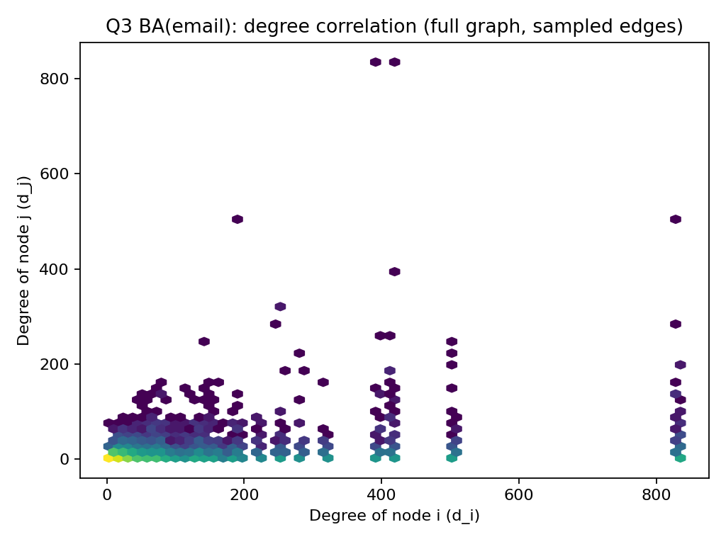
Figure F3 powergrid
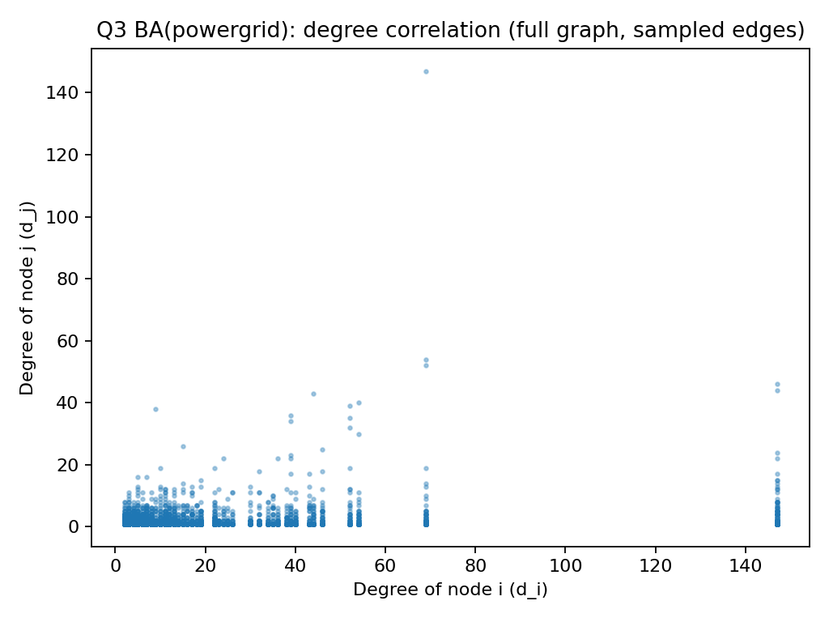
Collaboration
- BA: $ρ≈0.264$(Fig. F1)
- Real: $ρ≈0.135$
- Interpretation: both are assortative, but BA is more assortative: preferential attachment tends to connect new nodes to popular nodes, which can inflate positive degree–degree correlation compared to the real collaboration network
Email
- BA: $ρ≈0.169$(Fig. F2)
- Real: $ρ≈-0.116$(disassortative)
- Interpretation: this is a key mismatch: the real email network has hub-to-low-degree mixing (negative correlation), while BA produces positive correlation, so BA does not capture the email network’s heterogeneous role structure
Powergrid
- BA: $ρ≈0.191$(Fig. F3)
- Real: $ρ≈0.024$(near zero)
- Interpretation: BA(powergrid) (with $m=1$) yields stronger positive mixing than the real grid, which is closer to neutral in degree correlations due to engineering/planarity-like constraints
BA produces positive degree correlations in all three cases, while the real graphs vary (notably email is disassortative), so BA does not reliably reproduce real-world mixing patterns.
(g)
For each BA graph, I computed local clustering coefficients $c_{i}$on the GCC for a sampled set of nodes, then plotted $c_{i}$versus degree $d_{i}$(scatter + binned trend).
Figure G1 collaboration degree vs clustering (GCC, sampled nodes)
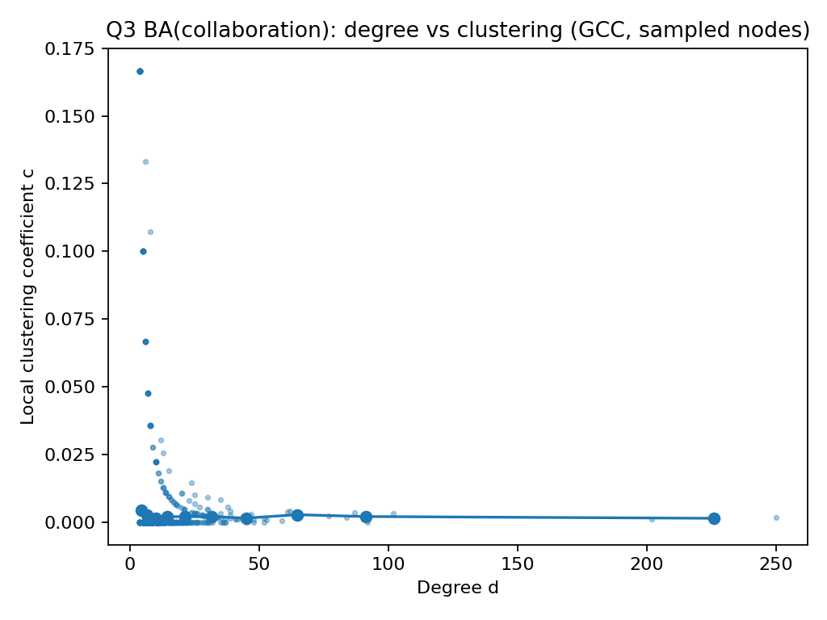
Figure G2 email
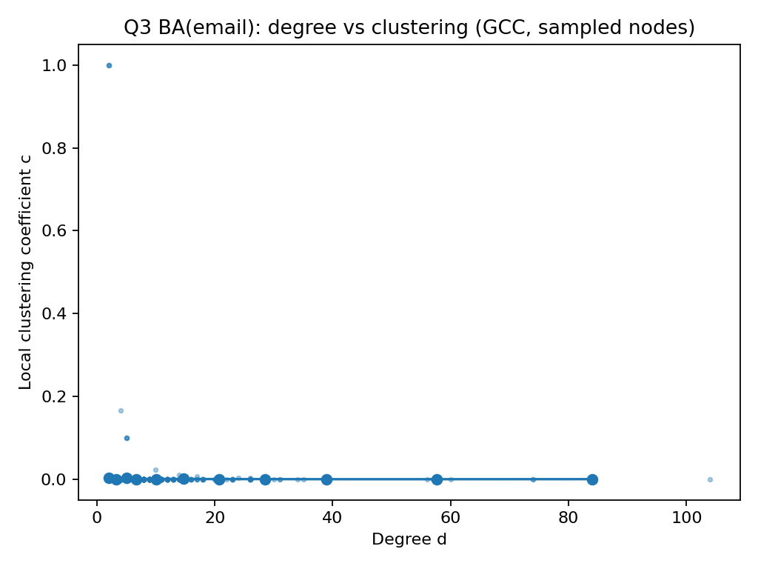
Figure G3 powergrid
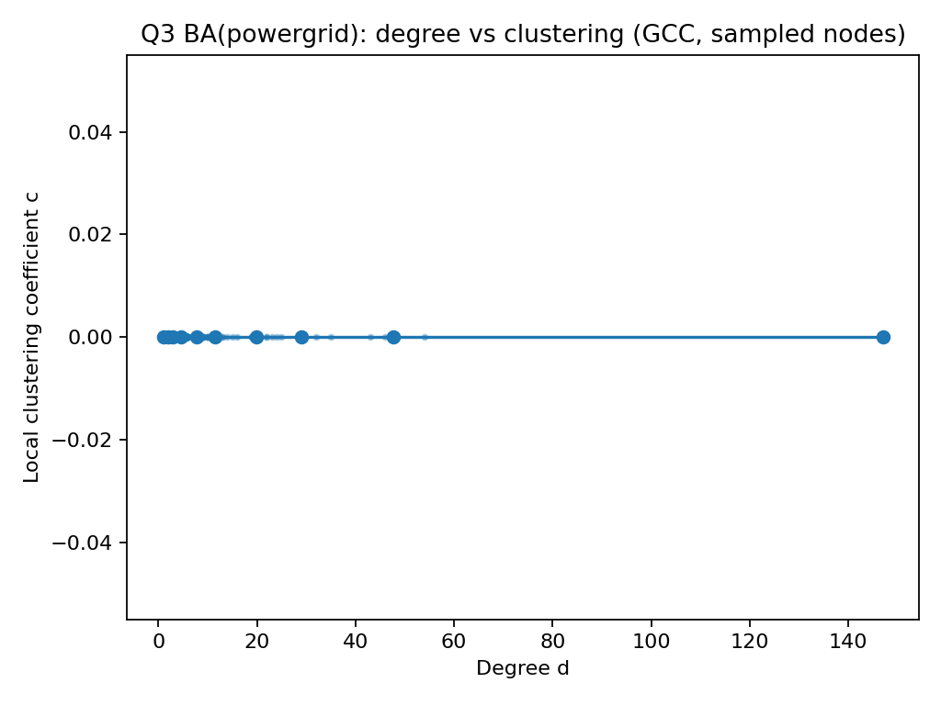
Collaboration
- BA: points concentrate near $c≈0$for almost all degrees (Fig. G1)
- Real: much higher clustering overall ($\overset{ˉ}{c}≈0.635$), with substantial clustering at small/moderate degrees
- Interpretation: BA’s triangle scarcity makes $c$stay near zero even as degree varies; the real collaboration network shows strong triadic closure, so the $d$–$c$ relationship is fundamentally different
Email
- BA: $c$is near zero across degrees (Fig. G2)
- Real: nonzero average clustering ($\overset{ˉ}{c}≈0.0429$) and visible clustering among low/moderate degrees
- Interpretation: real email communication has local group structure (triangles), but BA produces almost none, flattening the degree–clustering pattern
Powergrid
- BA: essentially $c≈0$everywhere (Fig. G3)
- Real: $\overset{ˉ}{c}≈0.0783$with some nodes exhibiting nontrivial clustering
- Interpretation: BA(powergrid) with $m=1$is tree-like (no triangles), so $c$collapses to ~0; real grids contain cycles/triangles from redundancy, giving a nonzero degree–clustering relation
In BA graphs, $c$is almost always $≈0$, so the $d$–$c$ relation becomes nearly flat at zero; real networks (especially collaboration) show meaningful clustering patterns that BA fails to reproduce.

